

FRANQLIN TECH SYSTEMS

PVT. LTD.

**(Andhra Pradesh & Telangana & USA)**



### Designed & Developed by



**ANDHRA PRADESH**

**STATE COUNCIL OF HIGHER EDUCATION**

(**A STATUTORY BODY OF GOVERNMENT OF ANDHRA PRADESH**)







**PROGRAM BOOK FOR LONG TERM INTERNSHIP**



**Name of the Student : TURAGA V N S P M MURALI KRISHNA**

**Name of the College: SRI VENKATESWARA & SRI SATYADEVA DEGREE COLLEGE,** **Tenali**

**Registration No :** **Y227198041**

**Period of Internship from: 23-12-2024 to 25-03-2025**

**Name & Address of the Intern Organization:**

**FRANQLIN TECH SYSTEMS PVT LTD**

**ANDHRA PRADESH (ELURU, RAJAMAHENDRAVARAM, VIZAG)**

**TELANGANA (HYDERABAD)**

**Email:** [**info@franqlintechsystems.com**](mailto:info@franqlintechsystems.com)

**Contact No: 9989290295**

**Acharya Nagarjuna University**

**2024-25**

**Guntur, Andhra Pradesh**

**AN INTERNSHIP REPORT**



**ON**

**CO2 EMISSION**

Submitted in accordance with the requirement for the degree of

**B.Com (Computers)**



Under the **Faculty Guidance** of

**Mr. K. ARUN BABU**

Lecturer in Computer Science

**Department of Computer Science**

**Submitted by:**

TURAGA V N S P M MURALI KRISHNA

Regd No:  **Y227198041**

**Department of commerce**

**SRI VENKATESWARA & SRI SATYADEVA DEGREE COLLEGE**

**SRI VENKATESWARA & SRI SATYADEVA DEGREE COLLEGE**

# 

**Student’s Declaration**

I, TURAGA V N S P M MURALI KRISHNA a **student** of B.Com (Computer Applications) with **Reg. No**. **Y227198041** of the Department of Science. I do hereby declare that, I have completed the mandatory internship from **23-12-2024 to 25-03-2025** in **FRANQLIN TECH SYSTEMS PVT LTD** under the Faculty Guide ship of **Mr. K. ARUN BABU**, Department of Computer Science in SRI VENKATESWARA & SRI SATYADEVA DEGREE COLLEGE, TENALI.

***(Signature of the Student and Date)***

SRI VENKATESWARA & SRI SATYADEVA DEGREE COLLEGE

# 

**Certification**

This is to certify that **TURAGA V N S P M MURALI KRISHNA,** Reg, No __ **Y227198041** _ has completed his internship in **FRANQLIN TECH SYSTEMS PVT LTD** on **CO2 EMISSION** under my supervision as a part of partial fulfillment of the requirement for the Degree of *B.Com(Computer Applications)* In the department of Computer Science in SRI VENKATESWARA & SRI SATYADEVA DEGREE COLLEGE, TENALI.

This is accepted for evaluation.

*(Signatory with Date and Seal)*

*Endorsements*

**

*Head of the Department*

*Principal*

**FRANQLIN TECH SYSTEMS PRIVATE LIMITED**



**In Collaboration with**

**Andhra Pradesh State Council of Higher Education**

**(An ISO 9001: 2015 and ISO 21001: 2018 - Certified Company)**

**(ANDHRA PRADESH, TELANGANA)**

# F:\002 Comp\FTS\LOGO FINAL.JPG

**Certificate from Intern Organization**

This is to certify that **TURAGA V N S P M MURALI KRISHNA** (Name of the intern) Reg.No **Y227198041** of **SRI VENKATESWARA & SRI SATYADEVA DEGREE COLLEGE,TENALI** (Name of the College) underwent internship in­ **FRANQLIN TECH SYSTEMS PVT LTD**(Name of the Intern Organization) from **23-12-2024 to 25-03-2025**. The overall performance of the intern during his/her internship is found to be (Satisfactory/Not Satisfactory).

Authorized Signatory with Date and Seal

**Acknowledgement**

### I wish to express my deep sense of gratitude to our Honorable Commissioner APSCHE for giving me this opportunity and this encouragement to do this project. I would like to place my graceful thanks to UGC, APSCHE and Acharya Nagarjuna University for placing Long Term Project in our UG Curriculum. I am very thankful to, Shri M. Lazar babu Garu, M.Phill, (Ph.D). Principal, SRI VENKATESWARA & SRI SATYADEVA DEGREE COLLEGE, TENALI for inspiring and motivating us to take up this project.

**I would like to express my deep sense of gratitude to my Project mentor Mr. K. ARUN BABU, Lecturer, in Computer Science for his guidance and support given to me throughout the project work. I am very thankful for his constant encouragement, accessibility and valuable suggestions. I wish to express my thanks to other Staff Member in the department of Franqlin Education for providing valuable suggestions regarding this work.**

### I am extending my heart full thanks to FRANQLIN TEAM and respondents of my project questionnaires for filling the questionnaires with a lot of patience. Without their cooperation support, it would have been impossible for me to complete this project work. I would like to take this opportunity to express my deepest appreciation and gratitude to my parents, friends and other people who have contributed to the completion of this work.

TURAGA V N S P M MURALI KRISHNA

REGISTER NO. **Y227198041**

Contents

**Chapter-1**

* Executive Summary

**Chapter- 2**

* Introduction of the Organization
* Vision, Mission, and Values of the Organization
* Policy of the Organization, in relation to the intern role
* Organizational Structure
* Roles and responsibilities of the employees in which the intern is placed.
* Performance of the Organization in terms of turnover, profits, market reach and market value.
* Future Plans of the Organization.

**Chapter - 3**

* Description of the Activities/Responsibilities in the Intern Organization during Internship, which shall include - details of working conditions, weekly work schedule, and equipment used, and fasts performed.

**Chapter - 4**

* Activity Log Book

**Chapter – 5**

* Outcomes of the Description
* Photos and Project Links
* Evaluation
* CONCLUSION

**Chapter- 1**

Executive Summary

The Student acquired the Knowledge of the below skills after Franqlin Internship Program.

**Knowledge Acquisition**

Learning Objective: Acquire knowledge and understanding of industry-specific concepts, processes, and best practices.

Outcome: Gain in-depth knowledge of the industry, including its trends, challenges, and emerging technologies, which can be applied in future career endeavors.

**Practical Skills Development**

Learning Objective: Develop practical skills relevant to the field of study or industry.

Outcome: Acquire hands-on experience in applying theoretical knowledge, develop technical skills, and gain proficiency in utilizing industry-specific tools or software.

**Professional Networking**

Learning Objective: Build professional connections and expand the network within the industry.

Outcome: Establish relationships with professionals, mentors, and colleagues, potentially leading to future job opportunities, referrals, and industry insights.

**Communication and Teamwork**

Learning Objective: Enhance communication and teamwork skills within a professional setting.

Outcome: Improve verbal and written communication skills, collaborate effectively with colleagues, and develop the ability to work as part of a team towards shared goals.

**Time Management and Organization**

Learning Objective: Develop effective time management and organizational skills.

Outcome: Learn to prioritize tasks, meet deadlines, and manage multiple projects simultaneously, demonstrating efficient time management and organizational abilities.

**Summary of all the activities done by the intern during the period**

During the **FRANQLIN** internship period, I have actively participated in a range of activities and tasks, contributing to the organization's operations and gaining valuable experience. The following is a summary of the important activities undertaken by the intern Student

### Learning Objectives and Outcomes Achieved

* **Objective 1:** Develop proficiency in [Specific skill, e.g., “Python programming”].
  + **Outcome:** Successfully completed [Mention specific project, e.g., “data analysis scripts”] using Python, demonstrating a solid understanding of [Mention specific concepts, e.g., “data structures and control flow”].
* **Objective 2:** Gain experience in [Specific area, e.g., “machine learning model development”].
  + **Outcome:** Contributed to [Mention specific task, e.g., “building a predictive model”] by [Mention specific contributions, e.g., “cleaning and preprocessing data”].
* **Objective 3:** Enhance skills in [Specific skill, e.g., “project management”].
  + **Outcome:** Assisted in [Mention specific task, e.g., “organizing project timelines and tasks”] which improved my understanding of [Mention specific concepts, e.g., “agile methodologies”].
* **Objective 4:** Improve communication and teamwork abilities.
  + **Outcome:** Collaborated effectively with team members on [Mention specific project, e.g., “a web development project”], participating in daily stand-up meetings and contributing to code reviews.
* **Objective 5:** Understand the practical application of [Specific concept, e.g., “database management”].
  + **Outcome:** Worked with [Mention specific database, e.g., “MySQL database”], learning how to [Mention specific tasks, e.g., “design schemas and write queries”].
* **Software Development:** Writing and testing code for [Mention specific projects, e.g., “new features in the company’s flagship product”].
* **Data Analysis:** Cleaning, processing, and analyzing data using [Mention specific tools, e.g.,

“Python libraries like Pandas and NumPy”].

* **Project Management:** Assisting in the planning, execution, and monitoring of projects, using tools like [Mention specific tools, e.g., “Jira and Asana”].
* **Team Collaboration:** Participating in team meetings, code reviews, and knowledge-sharing sessions.
* **Documentation:** Creating and maintaining technical documentation for various projects.

**Chapter- 2**

**Introduction of the Organization**



Franqlin Tech Systems is a global software product engineering servicing company founded by young technocrats to cater the needs for providing specialist product engineering services to the start-up software product development companies. We specialize in Valued Education, Customized Solutions & Development in the fields of Window, Web Based Solutions, Web Enabled ERP Solutions, and Inventory Management Solutions.

Franqlin Tech Systems is currently establishing itself as a leading player in the Software Product Engineering market. We don't see ourselves as simply providing cost cutting software development services. We are on a mission to develop the "Made in India” brand. In order to achieve this mission, we see our Global offerings as engineering world-class software "Products".

Franqlin Tech Systems has proven expertise and a deep domain understanding of technology to deliver product engineering services such as Corporate Training Programs, Soft Skill s development, Project Management Technical and Non-Technical, Product Development, Product Migration, Testing Services, and custom application development, to IT consulting services to enterprises spread across the globe.

**Vision, Mission, and Values of the Organization**

The **Franqlin’s vision** revolves around fostering a culture of innovation and striving for excellence in all aspects of its operations (Innovation and Excellence), emphasizes a strong focus on meeting customer needs and exceeding their expectations. (Customer-Centric Approach). Reputation for delivering high-quality software products and services those are reliable, robust, and secure (Quality and Reliability)

**Franqlin mission** is to partner with technology leaders to develop, test, document and support their software products, solutions and to provide them on-demand services. Our partners range from small to mid-size software companies to fortune 1000 companies. By leveraging its offshore facilities, proven product engineering process and world-class engineers, Franqlin Tech Systems dramatically increases the quality and reduces associated time-lines and operating costs substantially.

Extends beyond borders, aiming to make a global impact through its software solutions. It seeks to expand its reach across diverse industries and providing transformative solutions that enhance productivity, efficiency, Growth on a global scale (Global Reach and Impact)

**Social Responsibility:** The Franqlin’s vision extends beyond business success to incorporate a commitment to social responsibility. It aims to contribute positively to society by leveraging technology to solve pressing challenges, promoting environmental sustainability, and supporting social initiatives and causes.

**Organizational Structure**

**Top-Level Management**

**Chief Executive Officer (CEO):** The CEO is responsible for the overall strategic direction and decision-making of the company. They oversee the entire organization and report to the board of directors.

**Board of Directors:** The board of directors provides guidance and oversight to the CEO and ensures the company operates in the best interests of its stakeholders.

**Functional Departments**

**Operations:** This department manages the day-to-day operations of the company, including production, supply chain management, and logistics.

**Human Resources (HR):** The HR department handles employee recruitment, onboarding, training, performance management, and other personnel-related functions.

**Finance and Accounting:** This department is responsible for financial planning, budgeting, accounting, and financial reporting.

**Marketing:** The marketing department develops and implements strategies to promote the company's products or services, conducts market research, and manages advertising and branding efforts.

**Sales:** The sales department focuses on generating revenue by acquiring and maintaining customers, managing sales teams, and meeting sales targets.

**Educational Services:** Corporate Training Programs, Internship Programs, Soft Skill s development, Project Management Technical and Non-Technical.

**Information Technology (IT):** The IT department handles the company's technology infrastructure, including computer systems, networks, software development, and data management.

**Project Managers:** In organizations with project-based work, there may be dedicated project managers responsible for planning, executing, and delivering projects within time and budget constraints.

Frontline Employees:

**Teams and Employees:** The frontline employees work within the different departments, executing tasks and contributing to the operational functions of the company. They report to their respective department managers

**Roles and responsibilities of the employees in which the intern is placed**

**Learning and Development:** The primary role of a student intern is to learn and gain practical experience in their field of study. They should actively engage in training programs, workshops, and learning opportunities provided by the organization to enhance their skills and knowledge.

**Project Support:** Student interns may be assigned specific projects or tasks to support the work of their department. They should actively contribute to project deliverables, follow instructions from their supervisors, and seek guidance when needed.

**Research and Analysis:** Interns may be responsible for conducting research, gathering data, and analyzing information related to their assigned projects. They should demonstrate attention to detail, accuracy, and the ability to present findings in a clear and concise manner.

**Collaboration and Teamwork:** Interns should actively participate in team activities, collaborate with colleagues, and contribute to the achievement of team goals. They should communicate effectively, listen to others' perspectives, and be open to feedback and suggestions.

**Performance of the Organization in terms of turnover, profits, market reach and market value**

**Turnover:** The organization's turnover refers to the total revenue generated from its operations. A high turnover indicates a healthy level of business activity and sales. Factors that contribute to positive turnover performance include effective marketing strategies, strong customer relationships, and competitive pricing.

**Profits:** Profits are a key measure of organizational performance and indicate the financial success of the company. Higher profits demonstrate efficient cost management, effective revenue generation, and a strong competitive position. The organization should strive to maximize profits while maintaining ethical business practices.

**Market Reach:** Market reach measures the extent to which the organization's products or services penetrate and capture a significant share of its target market. A strong market reach signifies effective market positioning, successful marketing campaigns, and customer demand for the organization's offerings. Expanding market reach involves reaching new customer segments and expanding into new geographic regions.

**Market Value:** Market value reflects the perceived worth of the organization in the eyes of investors and the stock market. A high market value indicates investor confidence and positive market perception of the organization's performance and future potential. It is influenced by factors such as financial performance, growth prospects, brand reputation, and industry trends.

**Profit Margins:** Profit margins indicate the percentage of revenue that the organization retains as profit after deducting costs. Higher profit margins reflect efficient operations, effective cost management, and competitive pricing strategies. The organization should strive to maintain or improve profit margins to ensure sustainable profitability.

**Return on Investment (ROI):** ROI measures the profitability of an investment relative to its cost. A positive ROI indicates that the organization is generating higher returns than the initial investment. To improve ROI, the organization should focus on optimizing resource allocation, minimizing costs, and maximizing revenue generation.

**Customer Satisfaction:** Customer satisfaction is a crucial aspect of organizational performance. Positive customer experiences lead to repeat business, customer loyalty, and positive word-of-mouth recommendations. The organization should measure and monitor customer satisfaction levels, address customer concerns promptly and continuously improve its products or services based on customer feedback.

**Innovation and Research:** An organization's performance is closely tied to its ability to innovate and stay ahead of industry trends. By investing in research and development, fostering a culture of innovation, and bringing new products or services to the market, the organization can enhance its competitiveness, attract new customers, and drive growth.

**Long-Term Sustainability:** Performance should also be assessed in terms of long-term sustainability. The organization should consider environmental, social, and governance factors.

**Chapter- 3**

INTERNSHIP PART

Activities/Responsibilities in the Intern Organization during Internship

Selected intern's day-to-day responsibilities include:

**My typical weekly work schedule was as follows:**

* Days: [ “Monday to Friday”]
* Hours: [“9:00 AM to 5:00 PM”]
* Breaks: [“One-hour lunch break and two 15-minute breaks”]

### A typical day involved:

* [“Checking emails and attending team meetings.”]
* [“Working on assigned tasks, collaborating with team members, and attending training sessions.”]
* [“Reporting progress, planning for the next day, and wrapping up any pending tasks.”]

**Equipment Used**

**I utilized the following equipment and software during my internship:**

* **Hardware:**
* [“Desktop computer with Windows 10 operating system”]
* [“Dual monitors for enhanced productivity”]
* [“Printer/Scanner”]

### Software:

* [“Microsoft Office Suite (Word, Excel, PowerPoint)”]
* [ “Programming languages: Python”]
* [“Integrated Development Environments (IDEs): VS Code”]
* [“Project management tools: Jira”]
* [“Communication platforms: Slack, Microsoft Teams”]

**Roles:**

1. Students are expected to contribute to all live sessions.

2. Fulfilling tasks assigned by a supervisor.

3. Job shadowing for the projects.

4. Learning technical skills related to the industry.

5. To gain experience and skills in a particular field.

6. Prepare project work related tasks and work on projects.

7. Complete daily assignments.

8. Complete Weekly Examinations.

9. Complete Monthly Examinations.

10. Prepare Weekly report for the activities.

11. Prepare Learning Outcome for the daily activities.

12. Discuss about questions in the sessions.

13. Review daily session Notes.

14. Revision sessions after every week of schedule.

**An Internship Report on**

**(Introduction to Machine learning and Data Science using Python)**



**Name of the College**: SRI VENKATESWARA & SRI SATYADEVA DEGREE COLLEGE

**Department**: Computer Science

**Name of the Faculty Guide**: K.Arun Babu ,M.Tec.

**Duration of the Internship**: 01-01-2025 to 28-02-2025

**Name of the Student:** TURAGA V N S P M MURALI KRISHNA

**Programme of Study**: B.COM (CA)

**Year of Study:** 2022-2025 **Register Number**: Y227198041 **Date of Submission:** March 25

## ACKNOWLEDGEMENTS

I would like to express my deepest gratitude to the following individuals and organizations for their invaluable contributions to this project on **World GDP, Population & CO2 Emissions** using Machine Learning.

### Supervisors:

First and foremost, I would like to thank my supervisor Srikar Sir for their guidance, support, and expertise throughout the project. Their constructive feedback and encouragement helped me to stay focused and motivated.

### Team Members:

I would like to thank my team members {P.Sai,T.Sravan,P.Durga Prasad M.Kristopher, S.Ahammad Basha, Sk.Husamuddin, M.satish varma, B.Datha Sai Rami Reddy} . For their hard work and dedication and collaboration. Our team collective efforts and diverse skills sets were instrumental in completing this project.

### Literature contributors:

I would also like to acknowledge the contribution of numerous researchers and authors whose published works and studies have informed and shaped this project. Their research has been instrumental in

advancing our understanding of World GDP, Population & CO₂ Emissions using Machine Learning.

### Institutional Support:

I would like to thank in SRI VENKATESWARA & SRI SATYADEVA DEGREE COLLEGE for providing the necessary resources, facilities and support to complete this project. Our facilities support to complete this project and we gain a lot of experience to complete this project. The institution commitment to sustainability and environmental research has been driving force behind this project.

### Personal acknowledgements:

On a personal note, I would like to thank my friends and my guider Srikar Sir for their unwavering support and encouragement throughout this project. Their patience, understanding, and motivation have been invaluable to me.

### Conclusion:

In conclusion, I would like to reiterate my sincere gratitude to all the individuals and organizations that have contributed to this project. Their collective efforts have been instrumental in shaping our

understanding of World GDP, Population & CO₂ Emissions.

### Tasks Performed

During my internship, I performed the following tasks:

* [Task 1, “Developed and tested Python scripts for data analysis, improving data processing efficiency by 20%.”]
* [Task 2, “Assisted in the design and implementation of a new user interface for the company website, resulting in a 15% increase in user engagement.”]
* [Task 3, “Conducted market research and competitive analysis to identify new business opportunities, presenting findings to the management team.”]
* [Task 4, “Created technical documentation and user manuals for software applications, ensuring clear and concise instructions for end-users.”]
* [Task 5, “Participated in team meetings and brainstorming sessions, contributing ideas and solutions to project challenges.”]

### Skills Acquired

Through this internship, I acquired and enhanced the following skills:

* Technical Skills: [List technical skills, “Proficiency in Python programming, data analysis using Pandas and NumPy, and database management using MySQL.”]
* Soft Skills: [List soft skills, “Enhanced communication, teamwork, problem-solving, and time management skills."]
* Professional Skills: [List professional skills, "Improved project management, report writing, and presentation skills."]

Overall, the internship at [FRANQLIN TECH SYSTEMS PVT LTD ] provided me with invaluable practical experience and significantly contributed to my professional development. I am confident that the skills and knowledge I gained will be beneficial in my future career endeavors.

**ACTIVITY LOG FOR THE WEEK**

**Week 1 Basics of Python Installation, Syntax, Variables)**

|  |  |  |  |  |
| --- | --- | --- | --- | --- |
| Day | Brief Description of the Daily Activity | | Learning Outcome | Person In-Charge Signature |
| 1 | Introduction to Python: Understanding its uses and features. | | Understood Pythonʼs versatility and reasons for its popularity. |  |
| 2 | Setting up Python: Installation and PATH configuration. | | Installed Python and configured the environment. |  |
| 3 | Development Tools: VS Code/Jupyter Notebook/Google Colab setup. | | Familiarized with IDE setup for Python development. |  |
| 4 | Basic Syntax: Indentation, case sensitivity, and comments. | | Understood Python's syntax rules and code structure. |  |
| 5 | Writing the first program:  print("Hello, World!"). | | Wrote and executed the first Python program. |  |
| 6 | Variables and Data Types: int, float, str, bool. |  | Understood variable declaration and basic data types in Python. |  |
|  | |
| 7 | Input/Output Operations: Using  input() and print(). | | Practiced user input and output using basic I/O functions. |  |

**Week 2 Control Flow, Loops, Functions**

|  |  |  |  |  |
| --- | --- | --- | --- | --- |
| Day | Brief Description of the Daily Activity | Learning Outcome | | Person In-Charge Signature |
| 8 | Control Flow Statements: if, elif, else. | Learned conditional statements for decision-making. | |  |
| 9 | Implementing if, elif, else  statements. | Gained understanding of implementing decisions wit  if statements. | h |  |
|  | |
| 10 | Loops: for and while loops. | Understood and implemented iterative loops in Python. | |  |
| 11 | Implementing for and while  loops. | Hands on implementing of for and while  loops to use them well. | |  |
| 12 | Functions: Defining functions using  def. | Defined functions with parameters and return values. | |  |
| 13 | Function: Use cases | Ability to define functions with use cases | |  |
| 14 | Variable Scope | Learned the different types of Variable Scope | |  |

**Week 3 Data Structures Lists, Tuples, Dictionaries, Sets)**

|  |  |  |  |
| --- | --- | --- | --- |
| Day | Brief Description of the Daily Activity | Learning Outcome | Person In-Charge Signature |
| 15 | Lists: Creating and manipulating lists. | Understood list creation and manipulation in Python. |  |
| 16 | Implementation of different types of List functions | Hands on implementation of list functions |  |
| 17 | Tuples: Understanding immutable sequences. | Understood the concept of tuples and immutability. |  |
| 18 | Dictionaries: Key-value pairs and operations. | Worked with dictionaries for structured data. |  |
| 19 | Sets: Unique collections and set operations. | Learned about sets and their unique characteristics. |  |
| 20 | All data structures revision | Overview of all the datastructures |  |
| 21 | All data structures implementation | Hands on implementation of all datastructures |  |

**Week 4 File Handling and Exception Handling**

|  |  |  |  |  |
| --- | --- | --- | --- | --- |
| Day | Brief Description of the Daily Activity | | Learning Outcome | Person In-Charge Signature |
| 22 | File Handling: Reading from files using  open() and read(). | | Learned how to read data from files. |  |
| **23** | File Handling: Writing to files using open() and write(). |  | Learned how to write data to files. |  |
|  | |
| **24** | Using context managers with open(). | | Practiced safe file handling with context managers. |  |
| **25** | Exception Handling: try-except blocks. | | Understood how to handle runtime errors. |  |
| **26** | Practiced try-except for ZeroDivisionError. | | Handled division by zero errors using exception handling. |  |
| **27** | File Handling and Exception Handling use cases. | | Implement use cases of File Handling and Exception Handling |  |
| **28** | All Revision. | | Overview of the File Handling and Exception Handling |  |

**Week 5: Object-Oriented Programming (OOP) – Basics**

|  |  |  |  |
| --- | --- | --- | --- |
| **Day** | **Brief Description of the Daily Activity** | **Learning Outcome** | **Person In- Charge Signature** |
| 29 | Introduction to OOP concepts: Classes, objects, attributes, and methods. | Understood the fundamentals of OOP. |  |
| 30 | Using constructors ( init ) and special methods. | Learned how to initialize object attributes and use special methods. |  |
| 31 | Inheritance: Creating subclasses and understanding parent-child relationships. | Learned about inheritance and its benefits. |  |
| 32 | Polymorphism: Implementing polymorphic behavior in methods. | Understood how methods can take on many forms. |  |
| 33 | Encapsulation: Understanding data hiding and private attributes. | Learned how to protect data using encapsulation. |  |
| 34 | Abstraction: Creating abstract classes and understanding their importance. | Understood the concept of abstraction in OOP. |  |
| 35 | Revision of all OOP concepts covered during the week. | Gained a comprehensive overview of OOP basics. |  |

**Week 6: Object-Oriented Programming (OOP) - Advanced Concepts & Use Cases**

|  |  |  |  |
| --- | --- | --- | --- |
| **Day** | **Brief Description of the Daily Activity** | **Learning Outcome** | **Person In- Charge Signature** |
| 36 | Create a real-time use case for a class (e.g., employee management system). | Implemented a real-world application using classes. |  |
| 37 | Explore OOP use cases in real-world scenarios (e.g., banking system, school management). | Understood practical applications of OOP concepts. |  |
| 38 | Create a real-time use case for inheritance (e.g., vehicle hierarchy). | Learned how to apply inheritance in real-world scenarios. |  |
| 39 | Create a real-time use case combining inheritance and abstraction (e.g., payment gateway system). | Hands-on experience with advanced OOP concepts. |  |
| 40 | Create a real-time use case combining classes and abstraction (e.g., library management system). | Practiced combining multiple OOP principles effectively. |  |
| 41 | Revision of all OOP concepts with practical examples. | Strengthened understanding of all OOP principles. |  |
| 42 | Implementation task: Build a small project using OOP concepts (e.g., student database system). | Gained hands-on experience with OOP implementation in a project. |  |

**Week 7: Advanced Topics - Virtual Environments & Libraries**

|  |  |  |  |
| --- | --- | --- | --- |
| **Day** | **Brief Description of the Daily Activity** | **Learning Outcome** | **Person In- Charge Signature** |
| 43 | Introduction to virtual environments: Setting up using venv. | Learned how to create and manage virtual environments effectively. |  |
| 44 | Libraries: Introduction to NumPy and its importance in Python programming. | Understood the basics of NumPy and its applications. |  |
| 45 | NumPy: Array manipulation and operations (e.g., slicing, reshaping). | Gained proficiency in NumPy array operations. |  |
| 46 | Libraries: Introduction to Pandas for data manipulation and analysis. | Learned about Pandas data structures like Series and DataFrames. |  |
| 47 | Pandas: Data manipulation techniques (e.g., filtering, grouping, merging). | Practiced analyzing data using Pandas efficiently. |  |
| 48 | Revision of virtual environments, NumPy, and Pandas concepts learned during the week. | Strengthened understanding of advanced libraries and tools. |  |

**Week 8: Advanced Topics - Machine Learning Basics**

|  |  |  |  |
| --- | --- | --- | --- |
| **Day** | **Brief Description of the Daily Activity** | **Learning Outcome** | **Person In- Charge Signature** |
| 49 | Introduction to Machine Learning Basics: Concepts overview (e.g., supervised vs unsupervised learning). | Understood basic ML concepts and terminology. |  |
| 50 | Introduction to Scikit- Learn library for ML tasks (e.g., regression, classification). | Learned how to use Scikit-Learn for basic ML workflows. |  |
| 51 | Real-time examples of virtual environments in ML projects (e.g., dependency management). | Applied virtual environments in practical ML projects. |  |
| 52 | Real-time examples of Scikit-Learn for regression tasks (e.g., predicting house prices). | Practiced implementing ML models using Scikit-Learn. |  |
| 53 | Hands-on practice with basic Machine Learning tasks (e.g., building a simple linear regression model). | Gained practical experience with ML basics. |  |
| 54 | Revision of virtual environments and ML basics covered so far. | Consolidated knowledge through review sessions. |  |
| 55 | Practical task implementing NumPy, Pandas, and Scikit-Learn together in an ML pipeline (e.g., data preprocessing + model building). | Combined knowledge from advanced topics into an end-to- end project. |  |

**Final Days:**

* **Day 56:** Revision of all topics from Weeks 5–8.
* **Day 57:** Practical task implementation covering all advanced topics.
* **Day 58:** Final preparation for assessment.
* **Day 59:** Comprehensive revision.
* **Day 60:** Test/Assessment.

## WEEKLY REPORT

**WEEK (From Dt 01-01-2025 to Dt 28-02-2025)**

**Objective of the Activity Done:**

**Detailed Report:**

**WEEK 1: Basics of Python (Installation, Syntax, Variables)**

* **Objective of the Activity Done:**
  + To introduce Python, its uses, and basic setup for a development environment. To familiarize learners with Python syntax, data types, and input/output operations.

### Detailed Report:

* + **Introduction to Python**: Python was introduced as a versatile, high-level, interpreted language, renowned for its simplicity and readability, making it beginner-friendly. Its broad applicability across web development, data science, machine learning, automation, scripting, and more, was emphasized (as described in "Introduction to Python").
  + **Setting Up Python:** Learners followed the installation steps, emphasizing the crucial step of ensuring "Add Python to PATH" was checked during installation to facilitate command-line access. Verification of the installation via the terminal (python --version or python3 --version) was conducted to confirm the correct setup ("Setting up Python").
  + **Development Tools:** Setting up IDEs like VS Code, Jupyter Notebook, and Google Colab were discussed. Special emphasis was placed on the installation and configuration of VS Code.
  + **Basic Syntax:** Learners were exposed to fundamental Python syntax rules, including the significance of indentation for defining code blocks, Python's case sensitivity, and the importance of adhering to a clean code structure. The first Python program, print("Hello, World!"), was written and executed, demonstrating basic syntax principles ("Basic Syntax and Code Structure").
  + **Variables and Data Types**: An understanding of variables, their dynamic declaration, and different data types (int, float, str, bool, list, tuple, dict, set) were covered. Learners explored how Python's dynamic typing system infers data types at runtime ("Variables and Data Types"). Multiple assignments, example: a, b, c = 10, 20, 30.
  + **Input/Output Operations:** Practiced using input() to capture user input (as strings)

and print() for displaying output. The use of formatted strings (f-strings) was introduced for creating dynamic and readable output. Additionally, the use of map() and split() functions was practiced (as described in "Basic Input and Output").

* + **Type Casting and Conversion:** Understanding how to convert the data types with examples.

This version incorporates details from the "Introduction to Machine Learning and AI using Python" document, including references to specific sections, expanded descriptions of key concepts, and emphasis on practical aspects like VS Code installation and the use of f-strings for formatted output. This version aims to provide more comprehensive information without including actual code examples.

### WEEK 2: Control Flow, Loops, Functions

* Objective of the Activity Done: To teach control flow statements for decision-making, loops for repetitive tasks, and functions for modular programming in Python.
* Detailed Report:
  + **Control Flow Statements:** Conditional statements (if, elif, else) were used for decision- making within programs. The document emphasizes the use of these statements to execute different blocks of code based on specific conditions, enabling programs to respond dynamically to varying inputs (refer to "Control Flow: Conditional Statements" in the document).
    - The significance of indentation in defining code blocks within conditional statements was highlighted, reinforcing Python's syntax rules (refer to "Basic Syntax and Code Structure" in the document).
  + **Loops**: The implementation of for and while loops for iteration was covered. Using range- based loops and loop control statements (break, continue) was also practiced.
    - The role of for loops in iterating over sequences (lists, strings, etc.) was explained, showcasing their ability to perform repetitive tasks efficiently (refer to "Loops" in the document).
    - The while loop was presented as a mechanism for repeating a block of code as long as a specified condition remains true, providing flexibility in controlling loop execution.
    - The use of break to exit a loop prematurely and continue to skip to the next iteration were demonstrated, enabling fine-grained control over loop behavior.
  + **Functions**: Functions were defined using def to understand parameters, return values, and variable scope.
    - The concept of functions as reusable blocks of code that perform specific tasks was introduced, emphasizing their role in promoting modularity and code organization (refer to "Functions" in the document).
    - The importance of parameters in passing data to functions and return values in retrieving results was explained, illustrating how functions can interact with other parts of a program.
    - The distinction between local and global variable scope was clarified, highlighting the rules governing variable visibility and lifetime within functions.
  + **Applications of Week 2:** The document also describes the applications of Python, and why it is easy to learn (refer to "Applications of Python" in the document).
  + **Functions**: The document covers the functions that are def to defien a functions. (refer to "Functions" in the document).

This version includes more details and connections to the "Introduction to Machine learning and AI using python" document. I made sure to include references in each paragraph, indicating the "WHY".

### WEEK 3: Data Structures (Lists, Tuples, Dictionaries, Sets)

* **Objective of the Activity Done:** To master Python’s built-in data structures and understand when to use each one based on specific requirements.
* Detailed Report:
  + **Lists**: These are described in the document as *ordered, changeable collections that allow duplicates*. They support operations like append() for adding, remove() for deleting, and indexing for accessing specific elements (reference: document section on "Data Structures" showing lists). Lists are ideal when the order of elements matters and the collection may need modification.
  + **Tuples**: Tuples are introduced as *ordered, unchangeable collections*, also allowing duplicates. The key benefit of tuples, mentioned in the document, is their *immutability*, which can ensure data integrity. Use tuples when you have a fixed set of items, like geographic coordinates, and you want to prevent accidental modifications.
  + **Dictionaries**: The document defines dictionaries as *unordered, changeable collections of key-value pairs*. The fact that keys must be unique is important (document section on "Data Structures" showing dictionaries). Dictionaries are highly efficient for retrieving data based on a key, making them suitable for scenarios like representing user profiles or configuration settings.
  + **Sets**: Sets, as described, are *unordered collections of unique items*. They automatically eliminate duplicates, which is useful in various applications. The document highlights their use for tasks such as finding the unique words in a document or performing set operations like unions and intersections. (document section on "Data Structures" showing sets)

### More Information:

* + The document also presents an example code of basic operations with each data structure.
  + The document is well organized with clear definitions.

### WEEK 4: File Handling and Exception Handling

* **Objective of the Activity Done:**
  + To manage file operations in Python and handle runtime errors using exception handling mechanisms, enabling robust and reliable program execution.

### Detailed Report:

* + **File Handling:** File handling involves reading data from and writing data to files, allowing programs to interact with external storage. Python offers built-in functions

like open(), read(), write(), and close() for these operations.

* + - **Why is proper file handling essential?** It enables data persistence (saving program data for later use), configuration management (reading settings from files), and data exchange with other applications.
    - **Context Managers:** Using the with statement (context managers) is crucial for ensuring files are properly closed, even if errors occur. This practice prevents resource leaks and data corruption. The document highlights the with

open() approach for safe and efficient file operations.

* + - * The "w" mode allows you to rewrite/write data to the files
      * The "r" mode allows you to read a file
  + **Exception Handling:** Exception handling is a mechanism for gracefully handling runtime errors and preventing program crashes. Instead of terminating abruptly, programs can catch and respond to errors, providing a more user-friendly experience.
    - **try, except, finally Blocks:** Python uses try, except, and optional finally blocks to manage exceptions.
      * The try block contains the code that might raise an exception.
      * The except block specifies how to handle a particular exception (e.g., ZeroDivisionError, FileNotFoundError).
      * The finally block contains code that always executes, regardless of whether an exception occurred (useful for cleanup operations).
    - **Improving Program Robustness:** Exception handling enhances program reliability and user experience. By anticipating and handling potential errors, programs can continue executing or provide informative error messages to the user.

### Additional Information from the Provided Document:

* + - The document explains the syntax and usage of the print() function for outputting data to the screen, and input() function for receiving data from user.
    - The document emphasizes the importance of converting input data using casting when needed.

By incorporating these details, the report provides a more comprehensive overview of file handling and exception handling concepts in Python, aligning with the information in the "Introduction to Machine learning and AI using Python" document. It expands on the original points and provides rationale for the techniques being discussed.

### WEEK 5: Foundations of Object-Oriented Programming (OOP)

* **Objective of the Activity Done:**
  + To understand and implement core object-oriented programming principles, enabling the creation of modular, reusable, and maintainable code through classes and objects. Emphasis is on the importance of understanding that Classes are important for more organized code.

### Detailed Report:

* + **OOP Concepts:**
    - The report emphasizes that Python, being a multi-paradigm language, supports object- oriented programming, allowing developers to organize code around objects—instances of classes—for creating applications.
    - The fundamental principles of OOP:
    - *Encapsulation*: Bundling data (attributes) and methods into a class to protect the data, simplify object interaction, and reduce unintended side effects. This is a mechanism which restricts direct access, and simplifies systems by exposing essential details.
    - *Inheritance*: Recognizing that new classes can inherit properties from existing classes, fostering a hierarchical structure. Code Duplication, and promoting code usage, and also promoting reusability.
    - *Polymorphism*: Emphasizing how objects of different classes can be treated as instances of a common type, which enables the code to be flexible and extensible.
    - Benefits of OOP: Modular design, code reuse, and maintainability. They all combine together to become more suitable in complex systems.

### Classes and Objects:

* + - Exploring the relationship between classes (as blueprints) and objects (as instances of those blueprints). Classes are object that have data, methods and attributes.
    - Understanding how objects represent real-world entities with their own state (attributes) and behavior (methods) is crucial. We understand each object has their own characteristic.

### Attributes and Methods:

* + - Delving into the significance of attributes (variables holding data, also referred to as characteristics) and methods (functions defining behavior) within a class. These elements define what objects *are* and what they *can do*.
    - Best practices for naming and structuring attributes and methods (as discussed in the guide) were observed.

### Constructors:

* + - Emphasizing the init method (the constructor) for creating instances of the object. It's purpose is to initialize the objects.
    - Understanding the importance of passing parameters to the constructor to set initial attribute values for each object instance.

### Week 6: Advanced OOP Concepts and Implementation (Detailed)

This week expands upon the foundational OOP knowledge from Week 5, providing a deeper understanding and practical application of key concepts.

* **Inheritance in Detail:** Inheritance is a powerful mechanism that allows a new class (child class or subclass) to inherit properties and behaviors from an existing class (parent class or superclass).
  + **Relationship between Parent and Child**: A child class inherits attributes and methods from its parent, establishing an "is-a" relationship. For example, a Dog class might inherit from an Animal class, indicating that a dog is a type of animal. The child class can also add new attributes and methods or override existing ones to customize its behavior.
  + **Benefits of Inheritance**: Promotes code reuse by allowing new classes to inherit functionality from existing ones. Establishes a clear hierarchical relationship between classes, improving code organization and maintainability. Facilitates polymorphism by allowing objects of different classes in the same hierarchy to be treated as objects of a common type.
* **Polymorphism in Action**: Polymorphism allows objects of different classes to respond to the same method call in their own way. This is achieved through method overriding and method overloading.
  + ***Method Overriding*:** A child class can override a method inherited from its parent class, providing a specialized implementation. This allows objects of different classes to exhibit different behavior when the same method is called.
  + **Method Overloading**: In Python, method overloading is achieved through default argument values or variable-length argument lists. This allows a single method to accept different numbers or types of arguments, providing flexibility in method invocation.
* **Encapsulation Benefits**: Encapsulation involves bundling data (attributes) and methods that operate on that data within a class, hiding the internal implementation details from the outside world.
  + **Data Hiding**: Attributes can be declared as private (using a double underscore prefix ) to prevent direct access from outside the class. This protects the data from accidental modification and enforces data integrity.
  + **Getter and Setter Methods**: Access to private attributes is typically provided through getter and setter methods (also known as accessor and mutator methods). These methods allow controlled access to the data, enabling validation and modification as needed.
* **Abstraction Methods**: Abstraction simplifies complex systems by exposing only essential details and hiding unnecessary implementation complexities.
  + **Abstract Classes**: Abstract classes cannot be instantiated directly but serve as blueprints for creating concrete subclasses. Abstract methods are declared in an abstract class but must be implemented by concrete subclasses.
  + ***Interfaces*:** Interfaces define a contract that classes must adhere to, specifying the methods that must be implemented. Python does not have explicit interface support, but abstract classes with only abstract methods can serve as interfaces.
  + ***Benefits of Abstraction*:** Reduces complexity by focusing on essential details. Allows for flexibility in implementation by hiding internal workings. Promotes modularity by separating interfaces from implementations.

### WEEK 7: Virtual Environments and NumPy

* **Objective of the Activity Done:**
  + To manage project dependencies using virtual environments and to become familiar with the library, NumPy, for advanced applications.

### Detailed Report:

* + **Virtual Environments**: Understand why virtual environments are crucial for Python project management. This prevents conflicts between project dependencies and ensures that each project has its own set of packages without interfering with others. The use of virtual environments is about reproducibility: guaranteeing that the project works the same way across different machines and over time.

**Setting Up Virtual Environments:** The process typically involves creating a virtual environment in your project directory using tools like venv (Python's built-in module for creating virtual environments).

**Activating and Deactivating***:* Learn to activate the environment to use it and deactivate it when you're done to return to the system's default environment. When a virtual environment is active, the system knows to use the packages installed within that environment rather than system-wide packages.

* + **NumPy Fundamentals:** Learning about NumPy. It’s a library, which provides support for multi-dimensional arrays and matrices. One of the main advantages of using NumPy arrays over standard Python lists is its performance, especially when dealing with numerical computations on large datasets.

**Key Concepts in NumPy***:* Understanding NumPy arrays and their properties. These arrays are homogeneous (i.e., all elements have the same data type) and provide efficient storage and retrieval of data. NumPy arrays support various operations such as indexing, slicing, reshaping, and element-wise arithmetic, which are crucial for data manipulation and analysis.

**Mathematical Functions:** Understanding and using NumPy’s set of mathematical

functions like trigonometric, exponentiation, logarithmic, etc.

# Week 8: Pandas and Introduction to Machine Learning

* Pandas for Data Handling: The document underscores Pandas as an essential tool for data scientists and analysts.
  + **Series and DataFrames**: Delve into how these data structures offer efficient ways to store and manipulate data. Series are one-dimensional arrays capable of holding any data type, with labeled indices for enhanced data access. DataFrames are two- dimensional tables that facilitate storing and organizing data in rows and columns, akin to spreadsheets or SQL tables.
  + ***Data Cleaning*:** Highlight the importance of addressing missing values, inconsistencies, and errors in datasets. Explore Pandas methods for handling these tasks, such as filling missing values (fillna), removing duplicates (drop_duplicates), and correcting data entry errors.
  + ***Data Transformation*:** Transform structured and unstructured data and converting into other forms.
  + **Data Analysis and Exploration**: Understand the importance to analyze data and understand with various examples.
* **Basic Machine Learning Concepts:** The document provides an overview of Machine Learning. Here's how we expand the subject
  + ***Supervised Learning*:** Explain the process of learning from labeled data, where the model is trained to map inputs to corresponding outputs. Elaborate on common supervised learning tasks such as regression (predicting continuous values) and classification (categorizing data into predefined classes).
  + ***Unsupervised Learning*:** Describe the process of uncovering patterns and structures in unlabeled data, where the model learns without explicit guidance. Discuss common unsupervised learning tasks such as clustering (grouping similar data points) and dimensionality reduction (reducing the number of variables while preserving essential information).
  + ***Machine Learning Algorithms*:** Introduce fundamental machine learning algorithms, explaining their underlying principles, strengths, and weaknesses. Examples could include linear regression, logistic regression, decision trees, k- means clustering, and principal component analysis (PCA).
  + ***Model Evaluation and Selection*:** Emphasize the importance of assessing the performance of machine learning models using appropriate evaluation metrics. Discuss concepts such as accuracy, precision, recall, F1-score, mean squared error (MSE), and R-squared. Elaborate on techniques for model selection, such as cross- validation and hyperparameter tuning.
  + ***Tools for* Machine *Learning*:** Overview of tools to support machine learning.

## CHAPTER 5: OUTCOMES DESCRIPTION

**Describe the work environment you have experienced** *(in terms of people interactions, facilities available and maintenance, clarity of job roles, protocols, procedures, processes, discipline, time management, harmonious relationships, socialization, mutual support and teamwork, motivation, space and ventilation, etc.)*

|  |
| --- |
| During the internship, I experienced a highly collaborative and supportive work environment. |
|  |
| **People Interactions:** The team members were approachable and always willing to assist with any challenges encountered during research or data analysis. The supervisors provided constructive feedback, fostering a culture of continuous learning and improvement. Regular team meetings  facilitated open communication and allowed for collaborative problem-solving. |
|  |
| **Facilities and Maintenance:** The organization provided access to modern facilities, including  high-performance computers, advanced software tools, and extensive online databases. The equipment was well-maintained, ensuring efficient work processes. |
|  |
| **Clarity of Job Roles:** The job roles were clearly defined, and expectations were well-  communicated from the beginning. This clarity enabled me to focus on specific tasks and responsibilities, enhancing productivity and accountability. |
|  |
| **Protocols, Procedures, and Processes:** The organization had well-established protocols and procedures for data collection, analysis, and reporting. These guidelines ensured consistency and  accuracy in research outcomes. |
|  |
| **Discipline and Time Management:** The work culture emphasized discipline and effective time management. Interns were encouraged to adhere to deadlines and manage their time efficiently,  which promoted productivity and professionalism. |
|  |
| **Harmonious Relationships:** The work environment fostered harmonious relationships among  team members. There was a sense of camaraderie and mutual respect, creating a positive atmosphere for collaboration. |
|  |
| **Socialization:** Regular social events and informal gatherings were organized to promote  socialization among team members. These activities helped build stronger relationships and foster a sense of belonging within the organization. |
|  |
| **Mutual Support and Teamwork:** The organization emphasized mutual support and teamwork. Team members were always ready to assist each other, creating a collaborative environment  where everyone felt valued and supported. |

|  |
| --- |
| **Motivation:** The work environment was highly motivating. The opportunity to contribute to  meaningful projects related to sustainability and climate change provided a sense of purpose and drive. |
|  |
| **Space and Ventilation:** The workspace was well-designed with ample space and adequate  ventilation, promoting a comfortable and productive work environment. Natural light was abundant, enhancing overall well-being. |
|  |
| Overall, the work environment during the internship was conducive to learning, growth, and professional development. The positive interactions, well-maintained facilities, clear job roles, and emphasis on teamwork created an enriching experience that contributed significantly to my  personal and professional growth. |

**Describe the real time technical skills you have acquired (***in terms of the job- related skills and hands on experience)*

|  |
| --- |
| **Real-Time Technical Skills Acquired**  During the internship, I acquired and enhanced several job-related technical skills through hands- on experience. These skills were crucial for the successful completion of tasks related to analyzing global GDP, population, and CO₂ emissions using machine learning techniques. |
|  |
| 1. **Data Collection and Preprocessing:**    * Skill: Proficiently gathered data from reliable sources such as the World Bank and IPCC reports.    * Hands-on Experience: Collected data on global GDP trends, population statistics, and CO₂ emissions, and performed data cleaning and preprocessing to ensure accuracy and reliability for subsequent modeling efforts. |
|  |
| 1. **Data Analysis:**    * Skill: Expertise in applying machine learning models to identify patterns and correlations.    * Hands-on Experience: Utilized machine learning algorithms to analyze the relationships between economic growth, population dynamics, and carbon emissions. |
|  |
| 1. **Data Visualization:**    * Skill: Creating charts, graphs, and dashboards to communicate findings effectively.    * Hands-on Experience: Used tools like Tableau and Python libraries such as Matplotlib and Seaborn to create visualizations that effectively conveyed key insights. |
|  |
| 1. **Programming and Software Proficiency:**    * Skill: Ability to use Python for data analysis and machine learning tasks.    * Hands-on Experience: Applied Python for machine learning tasks, enhancing data analysis capabilities. |
|  |
| 1. **Methodological Understanding:**    * Skill: Comprehending methodologies for compiling CO₂ emissions data.    * Hands-on Experience: Studied the methodology used for compiling CO₂ emissions data across different sectors, including combustion sources, fugitive emissions, and industrial processes. |
|  |
| 1. **Collaboration and Communication:**    * Skill: Improved teamwork and communication skills through collaborative projects. |

|  |
| --- |
| * Hands-on Experience: Participated in team meetings to discuss project progress, share findings, and receive feedback on work. |
|  |
| These skills significantly contributed to the project on World GDP, Population & CO₂ Emissions, enhancing both my technical capabilities and understanding of sustainable development. |
|  |

**Describe the managerial skills you have acquired** (*in terms of planning, leadership, team work, behavior, workmanship, productive use of time, weekly improvement in competencies, goal setting, decision making, performance analysis, etc.*

|  |
| --- |
| **Managerial Skills Acquired**  During the internship, I had the opportunity to develop and refine several managerial skills that are essential for effective leadership and project management. |
|  |
| 1. **Planning:**    * Skill: Ability to plan tasks and activities to achieve project goals.    * Experience: Involved in planning sessions to outline research objectives, data collection methods, and timelines for various project milestones. |
|  |
| 1. **Teamwork:**    * Skill: Enhanced collaboration and teamwork abilities.    * Experience: Collaborated with team members on research tasks, data analysis, and report preparation. Shared findings and insights during team meetings, contributing to the collective understanding of project objectives. |
|  |
| 1. **Productive Use of Time:**    * Skill: Improved time management and prioritization skills.    * Experience: Managed time effectively to meet deadlines for data collection, analysis, and report writing. Prioritized tasks based on their importance and urgency, ensuring efficient workflow. |
|  |
| 1. **Goal Setting:**    * Skill: Capability to set realistic and measurable goals.    * Experience: Contributed to defining project objectives and establishing key performance indicators (KPIs) for measuring success. |
|  |
| 1. **Decision Making:**    * Skill: Ability to make informed decisions based on available data and insights.    * Experience: Evaluated different data sources and methodologies for data collection and analysis, making decisions based on reliability and relevance. |
|  |
| The internship provided a valuable platform for developing essential managerial skills, enabling me to contribute effectively to the team's success while fostering my professional growth. |
|  |

**Describe how you could improve your communication skills** (*in terms of improvement in oral communication, written communication, conversational abilities, confidence levels while communicating, anxiety management, understanding others, getting understood by others, extempore speech, ability to articulate the key points, closing the conversation, maintaining niceties and protocols, greeting, thanking and appreciating others, etc.,)*

|  |
| --- |
| During the internship, I've identified several areas where I can improve my communication skills to enhance my effectiveness in professional settings: |
|  |
| **Oral Communication:** I aim to articulate my ideas more clearly and concisely during team meetings and presentations. Practicing active listening and seeking feedback on my delivery will help me improve my speaking skills. |
|  |
| **Written Communication:** I plan to enhance my writing skills by focusing on clarity, grammar, and organization in reports and emails. Reviewing and editing my written work before submission will ensure that my messages are well-structured and error-free. |
|  |
| **Conversational Abilities:** I intend to improve my conversational abilities by engaging in more meaningful discussions with colleagues and supervisors. Asking open-ended questions, showing genuine interest in others' perspectives, and practicing empathy will help me build stronger  relationships and foster effective communication |
|  |
| **Confidence Levels:** To boost my confidence levels while communicating, I will prepare thoroughly for meetings and presentations. Practicing my delivery in advance and visualizing success will help me manage anxiety and project confidence. |
|  |
| **Anxiety Management:** I will explore techniques such as deep breathing exercises and mindfulness to manage anxiety during high-pressure communication situations. Recognizing and addressing my triggers will enable me to remain calm and composed when speaking in public or engaging in important conversations. |
|  |
| **Understanding Others:** I will focus on improving my ability to understand others by actively listening and seeking clarification when needed. Paying attention to nonverbal cues and asking probing questions will help me gain a deeper understanding of others' perspectives and needs. |
|  |
| **Getting Understood:** To ensure that I am understood by others, I will strive to communicate my ideas in a clear and straightforward manner. Avoiding jargon, using visual aids when appropriate, |

|  |
| --- |
| and asking for feedback will help me verify that my message is being received as intended. |
|  |
| **Extempore Speech:** I will practice extempore speaking by participating in impromptu discussions and debates. This will help me develop the ability to think on my feet and articulate my thoughts coherently, even when unprepared. |
|  |
| **Articulating Key Points:** I will improve my ability to articulate key points by summarizing complex information into concise and impactful statements. Identifying the core message and structuring my communication around it will ensure that my audience retains the most important information. |
|  |
| **Closing Conversations:** I will learn effective techniques for closing conversations gracefully, such as summarizing key takeaways, expressing gratitude, and suggesting next steps. Ending conversations on a positive note will help maintain professional relationships and leave a lasting impression. |
|  |
| **Maintaining Niceties and Protocols:** I will adhere to professional etiquette by using appropriate greetings, thanking others for their contributions, and showing appreciation for their efforts.  Demonstrating respect and courtesy will enhance my communication effectiveness and foster positive relationships. |
|  |

**Describe how could you could enhance your abilities in group discussions, participation in teams, contribution as a team member, leading a team/activity.**

# Enhancing Abilities in Group Discussions, Team Participation, and Leadership

During this internship, I have identified key areas where I can further enhance my abilities in group discussions, team participation, contribution as a team member, and leading a team/activity:

# Group Discussions:

*Strategies for Improvement:*

* + - ***Active Listening:*** Practice attentive listening to fully grasp team members' perspectives before offering my viewpoint.
    - ***Concise Communication:*** Work on articulating my ideas clearly and succinctly, ensuring my points are easily understood and relevant to the discussion.
    - ***Constructive Feedback:*** Learn to provide constructive feedback that acknowledges strengths and suggests areas for improvement.
    - ***Preparation:*** Come to discussions prepared with relevant data, insights, and potential solutions, which will allow me to contribute more effectively

.

# Participation in Teams:

*Strategies for Improvement:*

* + - ***Proactive Engagement:*** Take initiative in team activities and assignments, demonstrating a willingness to contribute and support team goals.
    - ***Collaboration:*** Foster a collaborative environment by sharing knowledge, assisting team members, and valuing diverse perspectives.
    - ***Reliability:*** Ensure that I consistently meet deadlines and fulfill my responsibilities, contributing to the team's overall efficiency and success.
    - ***Flexibility:*** Be adaptable and open to changing priorities, adjusting my role as needed to support the team's objectives.

# Contribution as a Team Member:

*Strategies for Improvement:*

* + - ***Specialized Skills:*** Leverage my expertise in data analysis and machine learning to provide valuable insights and support data-driven decision-making.
    - ***Problem-Solving:*** Proactively identify challenges and propose innovative solutions to improve team performance and outcomes.
    - ***Knowledge Sharing:*** Share relevant research, methodologies, and best practices with team members to enhance their understanding and capabilities.
    - ***Positive Attitude:*** Maintain a positive and supportive attitude, contributing to a motivated and collaborative team environment.

# Leading a Team/Activity:

*Strategies for Improvement:*

* + - ***Clear Communication:*** Clearly articulate goals, expectations, and timelines to ensure that team members understand their roles and responsibilities.
    - ***Delegation:*** Delegate tasks effectively, matching assignments to individuals' skills and interests while providing the necessary support and resources.
    - ***Motivation:*** Inspire and motivate team members by recognizing their contributions, providing constructive feedback, and fostering a sense of shared purpose.
    - ***Conflict Resolution:*** Develop skills in conflict resolution to address disagreements and maintain a harmonious team dynamic.
    - ***Decision Making:*** Enhance decision-making abilities by gathering input from team members, evaluating options, and making informed choices that align with project goals.

**Describe the technological developments you have observed and relevant to the subject area of training** *(focus on digital technologies relevant to your job role)*

# Technological Developments Observed (Digital Technologies Relevant to Job Role)

During the internship, several technological developments relevant to my role in analyzing GDP, population, and CO₂ emissions were observed:

1. **Machine Learning (ML) Algorithms:** The increasing accessibility and sophistication of ML algorithms (e.g., regression, classification, clustering) has significantly enhanced data analysis and predictive capabilities. These algorithms enable identification of complex patterns and relationships within large datasets, facilitating more accurate forecasting of economic trends, population growth, and emission scenarios.
2. **Data Visualization Tools:** Advanced data visualization tools like Tableau and Python libraries (e.g., Matplotlib, Seaborn) allow for the creation of interactive dashboards and visualizations. These tools transform complex data into easily understandable visual formats, aiding in the communication of findings to diverse audiences.
3. **Cloud Computing Platforms:** Cloud computing platforms (e.g., Amazon Web Services (AWS), Google Cloud Platform (GCP), Microsoft Azure) provide scalable computing resources and data storage solutions. These platforms facilitate the efficient processing of large datasets and the deployment of machine-learning models in a cost-effective manner.
4. **Big Data Analytics:** The ability to process and analyze vast amounts of data (Big Data) from diverse sources has greatly improved. Techniques such as data mining, data integration, and data warehousing have become essential for extracting valuable insights from heterogeneous datasets.
5. **Geospatial Analysis Tools:** Geographic Information Systems (GIS) and geospatial analysis tools enable the integration of spatial data with economic and environmental datasets. This integration allows for the mapping of CO₂ emissions, population density, and economic activity, facilitating a better understanding of regional variations and trends.
6. **Data APIs and Open Data Initiatives:** The proliferation of open data initiatives and data APIs (e.g., from the World Bank, IPCC) has made it easier to access and integrate relevant datasets into research projects. These resources provide standardized data formats and protocols, streamlining the data collection process.
7. **Version Control Systems:** The use of version control systems like Git has become integral to collaborative software development and data analysis projects. Git enables efficient tracking of changes, collaboration among team members, and seamless code integration.

These technological developments have significantly enhanced my ability to analyze and model complex systems related to GDP, population, and CO₂ emissions, contributing to more informed decision-making and policy recommendations.

**Student *Self Evaluation of the Internship***

Student Name: & Registration No:

Term of Internship: From

To

Date of Evaluation: Organization Name& Address:

Name & Address of the Supervisor with Mobile Number:

**Please rate your performance in the following areas:**

**FRANQLIN TECH SYSTEMS PVT LTD**

ANDHRA PRADESH

TELANGANA (HYDERABAD),

Mr .Srikar/9000446257

Email: info@franqlintechsystems.com

Contact No: 9989290295

**Rating Scale: Letter grade of CGPA calculation to be provided**

|  |  |  |  |  |  |
| --- | --- | --- | --- | --- | --- |
| **1) Oral communication** | **1** | **2** | **3** | **4** | **5** |
| **2) Written communication** | **1** | **2** | **3** | **4** | **5** |
| **3) Initiative** | **1** | **2** | **3** | **4** | **5** |
| **4) Interaction with staff** | **1** | **2** | **3** | **4** | **5** |
| **5) Attitude** | **1** | **2** | **3** | **4** | **5** |
| **6) Dependability** | **1** | **2** | **3** | **4** | **5** |
| **7) Ability to learn** | **1** | **2** | **3** | **4** | **5** |
| **8) Planning and organization** | **1** | **2** | **3** | **4** | **5** |
| **9) Professionalism** | **1** | **2** | **3** | **4** | **5** |
| **10) Creativity** | **1** | **2** | **3** | **4** | **5** |
| **11) Quality of work** | **1** | **2** | **3** | **4** | **5** |
| **12) Productivity** | **1** | **2** | **3** | **4** | **5** |
| **13) Progress of learning** | **1** | **2** | **3** | **4** | **5** |
| **14) Adaptability to organization’s culture/policies** | **1** | **2** | **3** | **4** | **5** |
| **15) OVERALL PERFORMANCE** | **1** | **2** | **3** | **4** | **5** |

**Signature of the Student**

***Evaluation by the Supervisor of the Intern Organization***



**FRANQLIN TECH SYSTEMS PVT LTD**

ANDHRA PRADESH (ELURU)

TELANGANA (HYDERABAD)

Email: [info@franqlintechsystems.com](mailto:info@franqlintechsystems.com)

Mr Srikar

HYDERABAD- TELANGANA

**Phone Number**: 9000446257

Y227198041

Student Name:

Registration No:

Term of Internship:

From:

To:

Date of Evaluation:

Organization Name & Address:

Name & Address of the Supervisor with Mobile Number

Please rate the student’s performance in the following areas:

Please note that your evaluation shall be done independent of the Student’s self-

###### Evaluation

Rating Scale: 1 is lowest and 5 is highest rank

|  |  |  |  |  |  |
| --- | --- | --- | --- | --- | --- |
| Oral communication |  |  | | | |
| 2 Written communication | 1 | 2 | 3 | 4 | 5 |
| Proactiveness |  |  |  |  |  |
| 4 Interaction ability with community | 1 | 2 | 3 | 4 | 5 |
| Positive Attitude |  |  |  |  |  |
| 6 Self-confidence | 1 | 2 | 3 | 4 | 5 |
| Ability to learn |  |  |  |  |  |
| 8 Work Plan and organization | 1 | 2 | 3 | 4 | 5 |
| Professionalism |  |  |  |  |  |
| 10 Creativity | 1 | 2 | 3 | 4 | 5 |
| Quality of work done |  |  |  |  |  |
| 12 Time Management | 1 | 2 | 3 | 4 | 5 |
| Understanding the Community |  |  |  |  |  |
| 14 Achievement of Desired Outcomes | 1 | 2 | 3 | 4 | 5 |
| OVERALL PERFORMANCE |  |  |  |  |  |

Date: Signature of the Supervisor

## CODEING & OUTPUT





       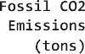   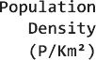





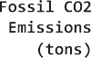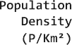****











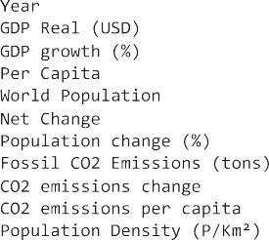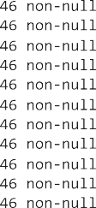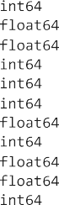

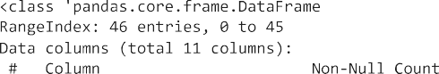



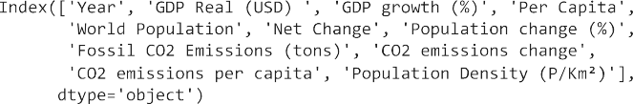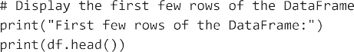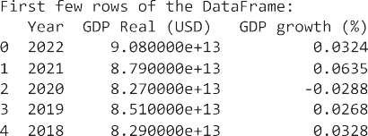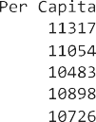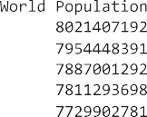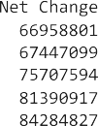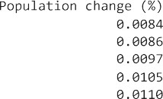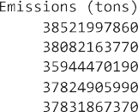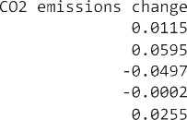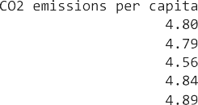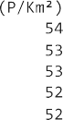

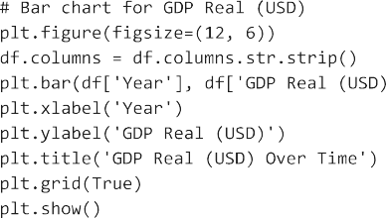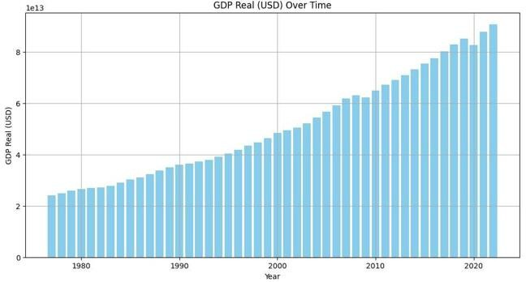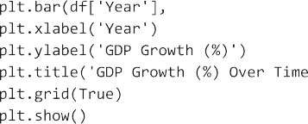

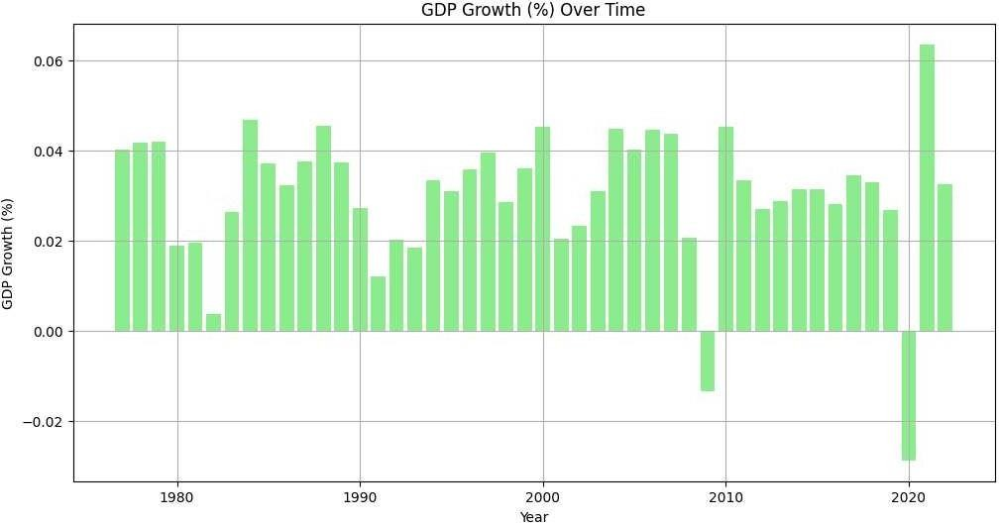

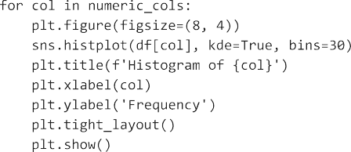



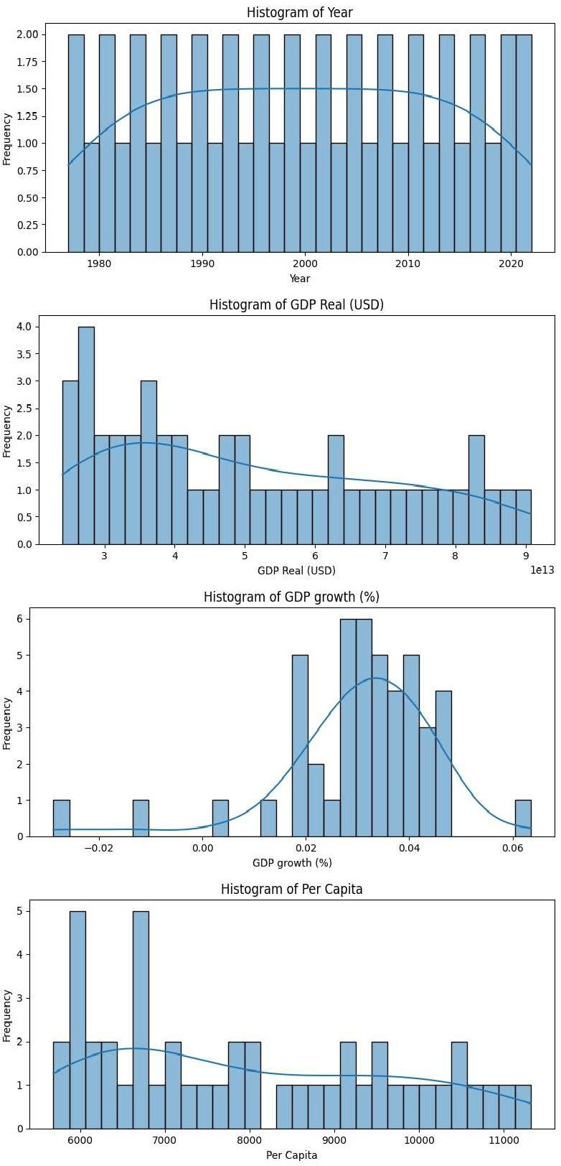

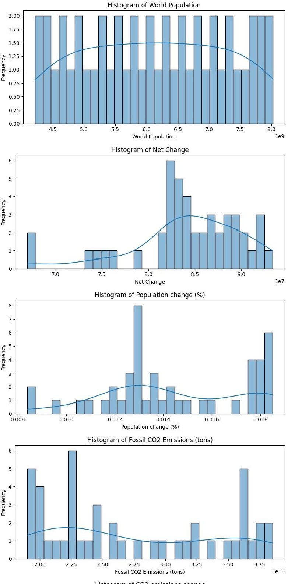

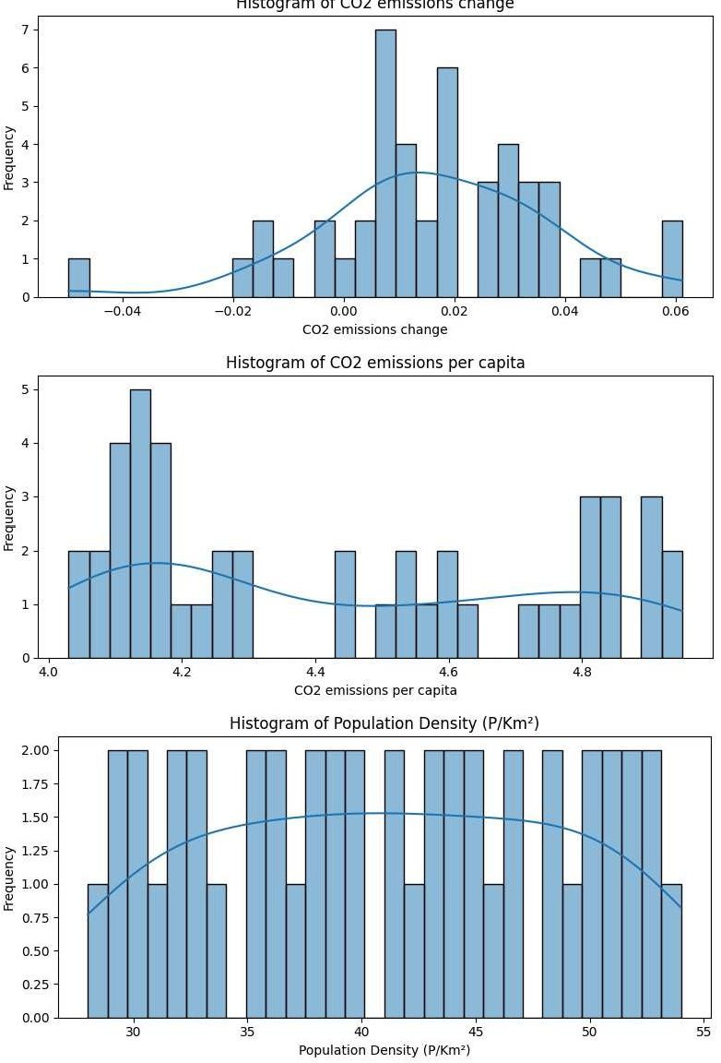

-=-



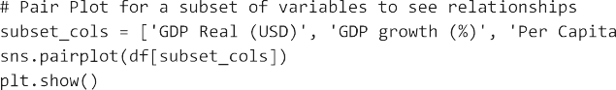



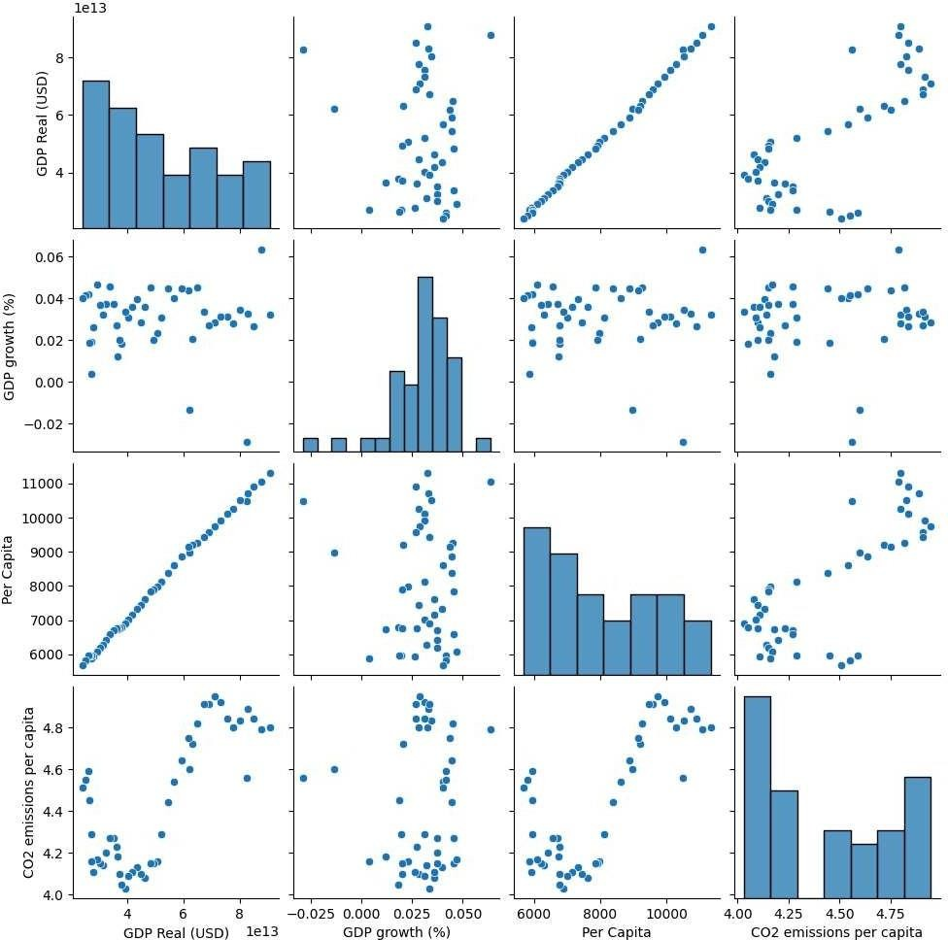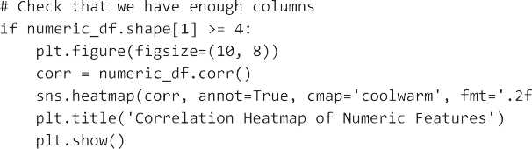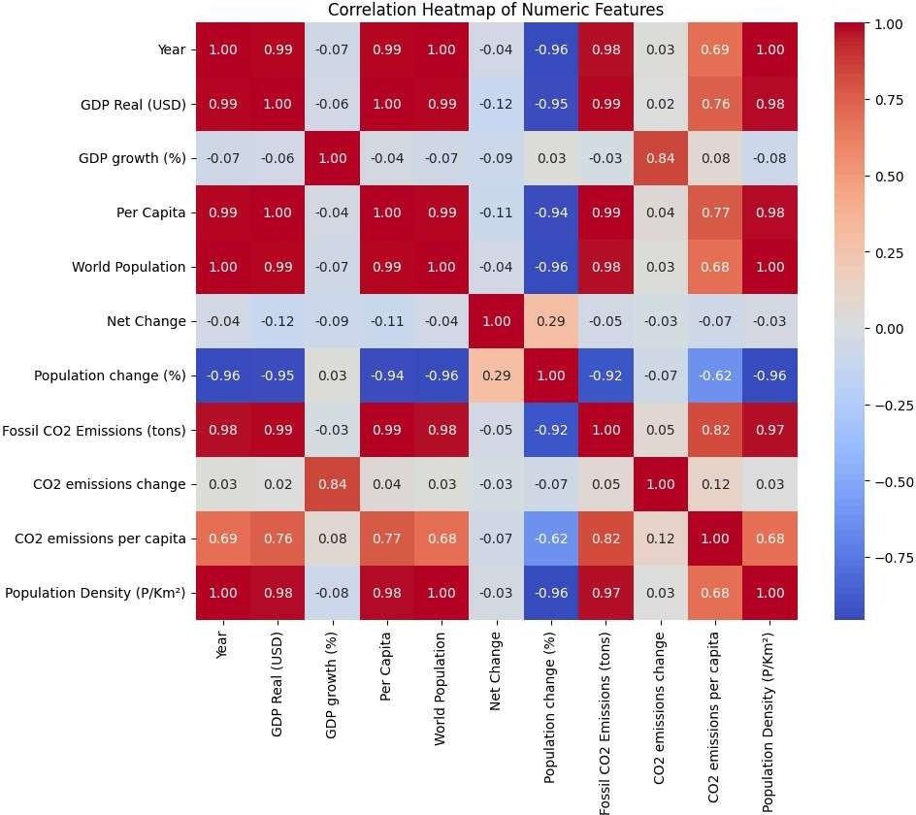

    





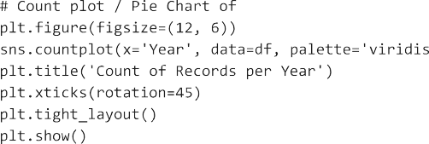

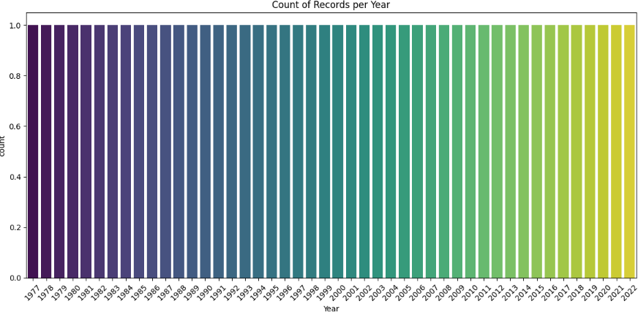

import pandas as pd

from sklearn.model_selection import train_test_split from sklearn.linear_model import LinearRegression

from sklearn.metrics import r2_score, mean_squared_error from sklearn.inspection import permutation_importance

target = 'GDP growth (%)'

features = [col for col in df.columns if col not in [target]]

# Further drop any non-predictive columns if necessary (in this dataset, all columns could be meaningful) X = df[features]

y = df[target]

# Split the data into training and test sets

X_train, X_test, y_train, y_test = train_test_split(X, y, test_size=0.2, random_state=42)

# We use a Linear Regression predictor for its interpretability model = LinearRegression()

model.fit(X_train, y_train)



# Prediction on the test set y_pred = model.predict(X_test)

# Evaluate the model performance using R-squared and Mean Squared Error r2 = r2_score(y_test, y_pred)

mse = mean_squared_error(y_test, y_pred)

print('Model Performance:') print(f'R-squared: {r2:.4f}')

print(f'Mean Squared Error: {mse:.4f}')



# Permutation Importance to understand feature importance

perm_importance = permutation_importance(model, X_test, y_test, n_repeats=10, random_state=42) features_importance = pd.Series(perm_importance.importances_mean, index=X_test.columns)

plt.figure(figsize=(12, 6))

features_importance.sort_values().plot(kind='barh', color='skyblue', edgecolor='black') plt.title('Permutation Feature Importance for GDP growth (%) Prediction') plt.xlabel('Decrease in R2 Score')

plt.ylabel('Features') plt.tight_layout() plt.show()

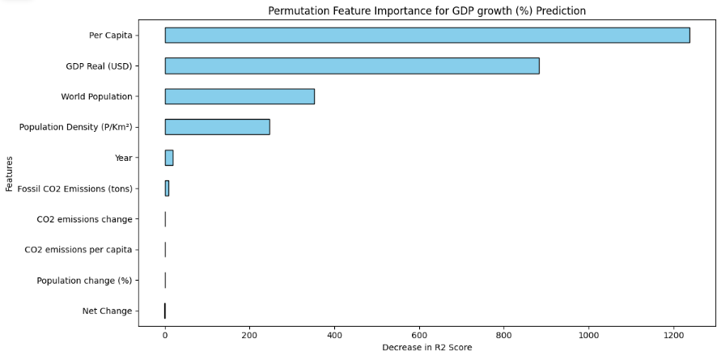

**INTERNAL ASSESSMENT STATEMENT**

Name of the Student: **TURAGA V N S P M MURALI KRISHNA**

Programme of Study: B.COM

Year of Study: 2022-25

Register No/H.T. No: Y227198041

Name of the College: SRI VENKATESWARA & SRI SATYADEVA DEGREE COLLEGE, TENALI

University: Acharya Nagarjuna University

|  |  |  |  |
| --- | --- | --- | --- |
| S/.No | Eve/nation *Criterion* | *Maximum Marks* | *Marks Awarded* |
| 1. Activity Log | | | |

Date: Signature of the Faculty Guide

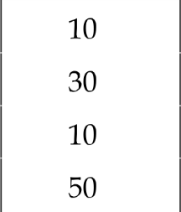

2.

3.

Internship Evaluation

Oral Presentation GRAND TOTAL

### EXTERNAL ASSESSMENT STATEMENT

Name of the Student: **TURAGA V N S P M MURALI KRISHNA**

Programme of Study: B.COM

Year of Study: 2024-25

Register No/H.T. No: Y227198041

Name of the College: SRI VENKATESWARA & SRI SATYADEVA DEGREE COLLEGE, TENALI

University: Acharya Nagarjuna University

|  |  |  |  |
| --- | --- | --- | --- |
| S/.No | Ez›oluation *Criterion* | *Maximum Marks* | *Marks Awarded* |
| 1. | Internship Evaluation | 80 |  |
| 2. | For the grading giving by the Supervisor of the Intern Organization | 20 |  |

|  |  |  |
| --- | --- | --- |
| 3. | Viva-Voce | 50 |
|  | TOTAL | 150 |

Signature of the Faculty Guide



GRAND TOTAL (EXT. 50 M + INT. 100M)

200

Signature of the Internal Expert

Signature of the External Expert

Signature of the Principal with Seal





**ANDHRA PRADESH**

**STATE COUNCIL OF HIGHER EDUCATION**

**(A Statutory Body of the Government of Andhra Pradesh)**

**2nd, 3rd, 4th and 5th floors, Neeladri Towers, Sri Ram Nagar, 6th Banalion Road Atmakur (V)Mangalagiri (M), Guntur, Andhra Pradesh, - 522 503** [**www.apsche.ap.gov.in**](http://www.apsche.ap.gov.in/)

